
Quality Management System Manual
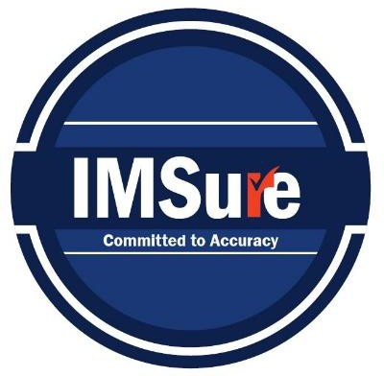
QSM-9000

Revision History and Approval
Date | Revision Summary | Approved by
 | - Updated references from AS9120 to AS9100.  - Included the Laser Department at Riverside and Phoenix in the scope.  - Detailed planning for quality objectives and risk management.  - Integrated safety policy and training procedures.  - Simplified and clarified language for better understanding. | Melissa DaSilva, Director of Quality

Contents
Revision History and Approval 1
1. Introduction 2
2. Mission, Vision, and Values 2
3. About This Manual 2
4. Context of the Organization 2
4.1 Understanding Our Context: 2
4.2 Scope: 2
4.3 Quality Management System and Its Processes: 3
5. Leadership 3
5.1 Leadership Commitment: 3
5.2 Quality Policy: 3
5.3 Safety Policy: 3
6. Planning 3
6.1 Actions to Address Risks and Opportunities: 3
6.2 Quality Objectives and Planning to Achieve Them: 3
7. Support 3
7.1 Resources: 3
7.2 Training: 3
7.3 Infrastructure: 3
7.4 Documented Information: 3
7.5 Competence and Awareness: 3
8. Operation 3
8.1 Operational Planning and Control: 3
8.2 Design and Development: 3
8.3 Purchasing: 3
8.4 Production: 3
8.5 Release of Products: 4
8.6 Control of Nonconforming Outputs: 4
8.7 Counterfeit Part Prevention: 4
9. Performance Evaluation 4
9.1 KPIs: 4
9.2 Internal Audit: 4
9.3 Management Review: 4
10. Improvement 4
10.1 Nonconformity and Corrective Action: 4
10.2 Continual Improvement: 4
Figures and Process Maps 5

1. Introduction
This manual describes the Quality Management System, and delineates authorities, interrelationships, and responsibilities of the personnel responsible for performing within the organization’s system, providing procedures or references for the activities comprising the Quality Management System, ensuring conformance to the requirements of ISO9001, AS9100, and AS6174A standards where appropriate, used internally and externally as an introduction to the QMS. The organization is committed to continual improvement and enhancing customer satisfaction.

2. Mission, Vision, and Values
Mission: Provide the most responsive, highest quality, and reliable service in our industry.
Vision: To be the most efficient metal service center.
Values: Integrity, learning, innovation, and customer-first approach.

3. About This Manual
This manual explains our interpretation and compliance with AS9100, AS6174A, and ISO 9001 standards.

4. Context of the Organization

Understanding Our Context:
We have 7 locations and over 75 years of experience specializing in Metal Sales and Cutting Services in California and Arizona. We stock a variety of metals and offer custom aluminum extrusion requests.

Scope:
Mill Distributor and Metal Service Center, including a Laser Department at Riverside and Phoenix for "Make/Build Products to customer specifications with limited design feedback." All other locations exclude design and manufacturing sections. We handle customer-owned materials (drawings or engineering documents) at Riverside and Phoenix.
Exclusions:
- 8.3 Design and Development: Excluded except for Riverside and Phoenix.
- 8.5.3 Customer Property: Excluded except for Riverside and Phoenix.

Quality Management System and Its Processes:
We use a process approach for our QMS, identifying top-level processes: Quality, Sales, Procurement, Warehouse Operations, and Logistics. These processes reduce the potential for nonconformities discovered during final processes or after delivery. Each process is included in the Process Flow Diagram.

5. Leadership

Leadership Commitment:
Top Management actively engages in developing, implementing, and improving the QMS. Risk-based thinking is integrated into our processes to identify and address potential risks and opportunities. This proactive approach ensures the effectiveness of the QMS and enhances customer satisfaction.

Quality Policy:
"We commit to continuous improvement and meeting customer requirements with accurate, responsive, reliable, and convenient service."
Roles and Responsibilities:
An organizational chart shows the inclusion of the Laser Department at Riverside and Phoenix. Our Director of Quality or a designated representative is responsible for maintaining and updating the QMS.

Safety Policy:
We maintain a safe work environment through regular training and adherence to safety protocols.

6. Planning

Actions to Address Risks and Opportunities:
The introduction of the Laser Department at the Riverside and Phoenix locations requires a comprehensive review of potential risks and opportunities. These will be managed through a Change Management Plan (CMP) detailing the risks, impacts, and mitigations.

Quality Objectives and Planning to Achieve Them:
The Laser Department will have specific quality objectives aligned with overall organizational goals. These will be reviewed and updated annually during management review. Objectives include on-time delivery, product quality, and customer satisfaction.

7. Support

Resources:
We provide necessary resources, including people, tools, equipment, and processes.

Training:
Mandatory training on safety processes and machine usage for personnel at Riverside and Phoenix. The LMS is updated to reflect training modules.

Infrastructure:
The floor plan for the Laser Cutting Center at Riverside and Phoenix ensures optimized workflow and safety.

Documented Information:
All processes and procedures are documented and controlled.

Competence and Awareness:
Staff members performing work affecting product quality are competent based on education, training, skills, and experience. Employees are made aware of their impact on the QMS and safety.

8. Operation

Operational Planning and Control:
Processes for sales, contract review, and risk planning for the Laser Department follow established procedures.

Design and Development:
The Laser Department provides design feedback but does not engage in full-scale product design.

Purchasing:
Managed by designated positions, ensuring compliance with quality standards.

Production:
Documented procedures and forms ensure process control and quality.

Release of Products:
Defined processes with follow-up actions ensure customer satisfaction.

Control of Nonconforming Outputs:
Nonconformities are managed through an integrated NCR process.

Counterfeit Part Prevention:
Operational controls prevent counterfeit parts from entering the supply chain.

9. Performance Evaluation

KPIs:
The Laser Department at Riverside and Phoenix locations will have specific KPIs, including On-Time Delivery (OTD) and Quality.

Internal Audit:
The internal audit checklist includes the scope of the Laser Department.

Management Review:
Management reviews include performance and improvement opportunities for the Laser Department.

10. Improvement

Nonconformity and Corrective Action:
The Laser Department follows procedures to address nonconformities and prevent recurrence.

Continual Improvement:
Management identifies and prioritizes improvement opportunities specific to the Laser Department.

Figures and Process Maps
Figure 1: Interested Parties Table
Figure 2: Business Process Map
Figure 3: Organizational Chart

Figure 1: Interested Parties Table
Interested Party | Needs | Expectations | QMS Risk | Mitigations and KPIs
Customers | Conforming Product delivered on time.  Contract Fulfillment | OTD/Quality at or above industry standards at a fair market price | Contract review,  Purchase order flow downs, Nonconformities | Mitigations: Management Review Customer Surveys Customer Feedback
KPIs:
OTD >X
Customer Satisfaction >X Quality Escapes <X
Employees | Safe work environment Remuneration/ benefits | Job security Recognition and reward Professional development  Good work/ life balance | Leave  Lack of attention Lack of training  Human Factors Impact | Mitigations: Town Hall Training  Growth Opportunities
KPIs:
Retention Rate Safety Scorecards
Key Suppliers/Partners | On time Payment Clear and accurate information Timely feedback | Communication Contract adherence Compliance to required regulations  Ethical Behavior | Failure to comply with requirements Management review incomplete | Mitigations:  Risk Management Contract Review
KPIs: OTD >X
Quality <X
Regulators, Statutory enforcers, Certification Bodies | Strict adherence to requirements Verification of system effectiveness | Good business practices  Health and Safety provisions  EPA fulfillment | Lack of Training Inaccurate or inconsistent audit process  Business Continuity | Mitigations: Management Review Internal Audit Training  3rd party auditing
KPIs:
Certification

Figure 2: Business Process Map
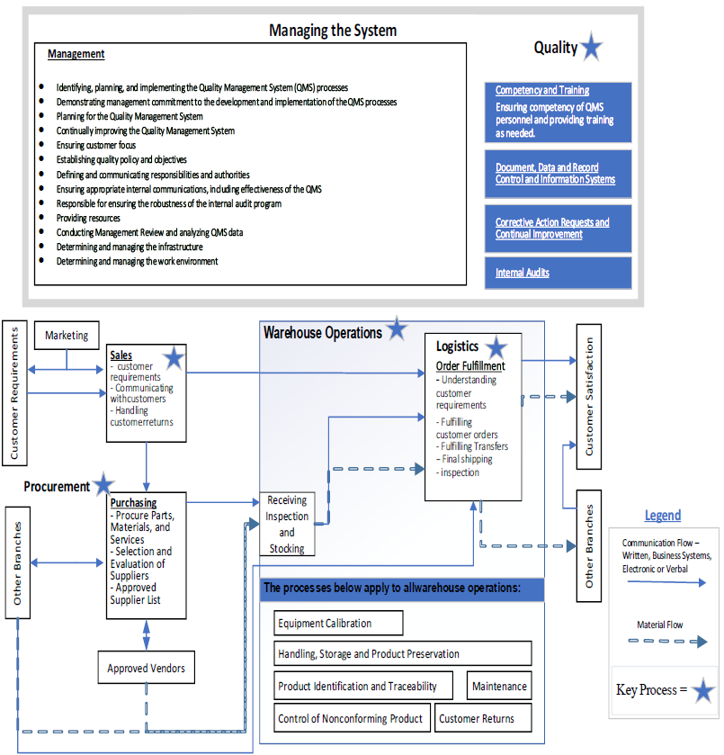

Figure 3: Organizational Chart
